Your Name |  |  | Lauren Mazzoli
Step / Points |  |  | Paste in your answers for each step below in this column. Paste your actual SQL text, not a screen shot of it. Paste a screen shot of your Result Grid. Be sure to “Snip” your screen shots.
1.1 | 3 | Result Grid | 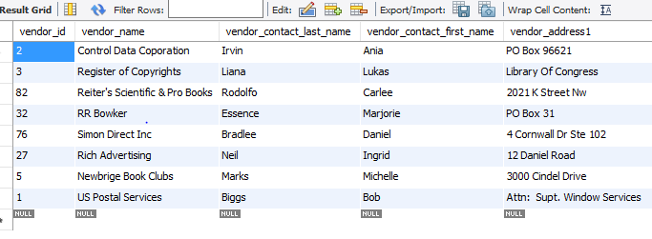
1.1 | 3 | SQL | SELECT  *  FROM  vendors  WHERE  vendor_state IN ('WI' , 'NJ', 'DC')  ORDER BY vendor_state , vendor_city
1.2 | 3 | Result Grid | 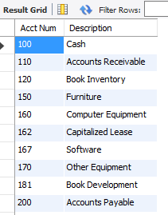
1.2 | 3 | SQL | SELECT  account_number 'Acct Num', account_description Description  FROM  general_ledger_accounts  ORDER BY account_number
1.3 | 3 | Result Grid | 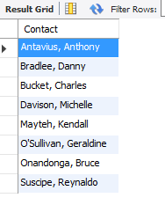
1.3 | 3 | SQL | SELECT  CONCAT(last_name, ', ', first_name) AS Contact  FROM  vendor_contacts  ORDER BY Contact
1.4 | 3 | Result Grid | 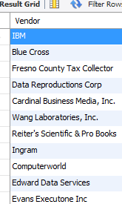
1.4 | 3 | SQL | SELECT DISTINCT  vendor_name Vendor  FROM  vendors  JOIN  invoices  WHERE  vendors.vendor_id = invoices.vendor_id
2.1 | 3 | Result Grid | 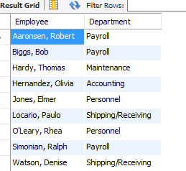
2.1 | 3 | SQL | SELECT  CONCAT(last_name, ', ', first_name) Employee,  department_name Department  FROM  employees  JOIN  departments ON employees.department_number = departments.department_number  ORDER BY Employee
2.2 | 6 | Result Grid | 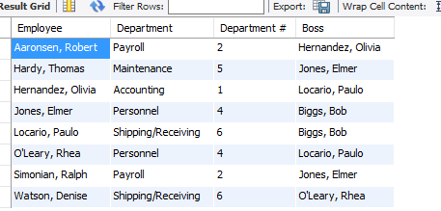
2.2 | 6 | SQL | SELECT  CONCAT(e1.last_name, ', ', e1.first_name) Employee,  d1.department_name Department,  d1.department_number 'Department #',  CONCAT(b1.last_name, ', ', b1.first_name) Boss  FROM  employees e1  JOIN  employees b1 ON e1.manager_id = b1.employee_id  JOIN  departments d1 ON e1.department_number = d1.department_number  ORDER BY Employee
2.2 | 6 | Explanation | This query lists all employees in the employee table that have a department and a boss. The employee’s Boss is found by using the employee’s manager id and self-joining to the employee table. The department name and number are found by linking to the department table through an outer join that references the employee’s department id. Employee and Boss are formatted suing the CONCAT operation and the results set is sorted by employee name.
2.3 | 3 | Result Grid | 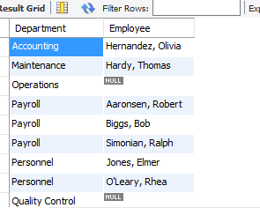
2.3 | 3 | SQL | SELECT  department_name Department,  CONCAT(e1.last_name, ', ', e1.first_name) Employee  FROM  departments  LEFT JOIN  employees e1 ON departments.department_number = e1.department_number  ORDER BY department_name, Employee
3.1 | 6 | Result Grid | 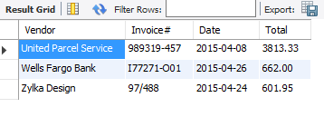
3.1 | 6 | SQL | SELECT  vendor_name Vendor,  invoice_number ‘Invoice#’,  invoice_date Date,  invoice_total Total  FROM  invoices  JOIN  vendors ON vendors.vendor_id = invoices.vendor_id  WHERE  invoice_total > 250  AND invoice_date BETWEEN '2015-04-01' AND '2015-04-30'  ORDER BY invoice_total DESC
 | 30 |  | Total Points

